Issues:

1. onselection of different tabs - it is always highlighting "Home" tab: Done

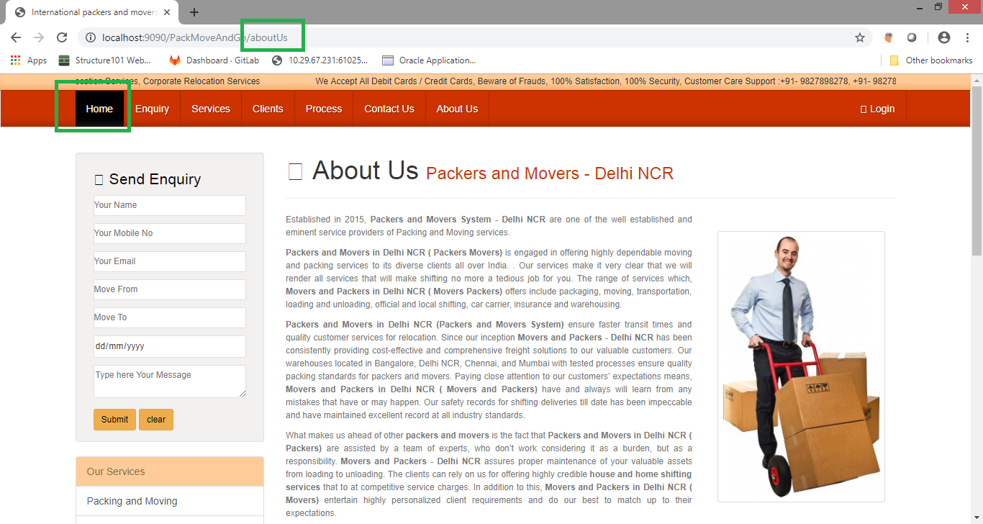

1. while using “Send Enquiry” it is showing error: Done

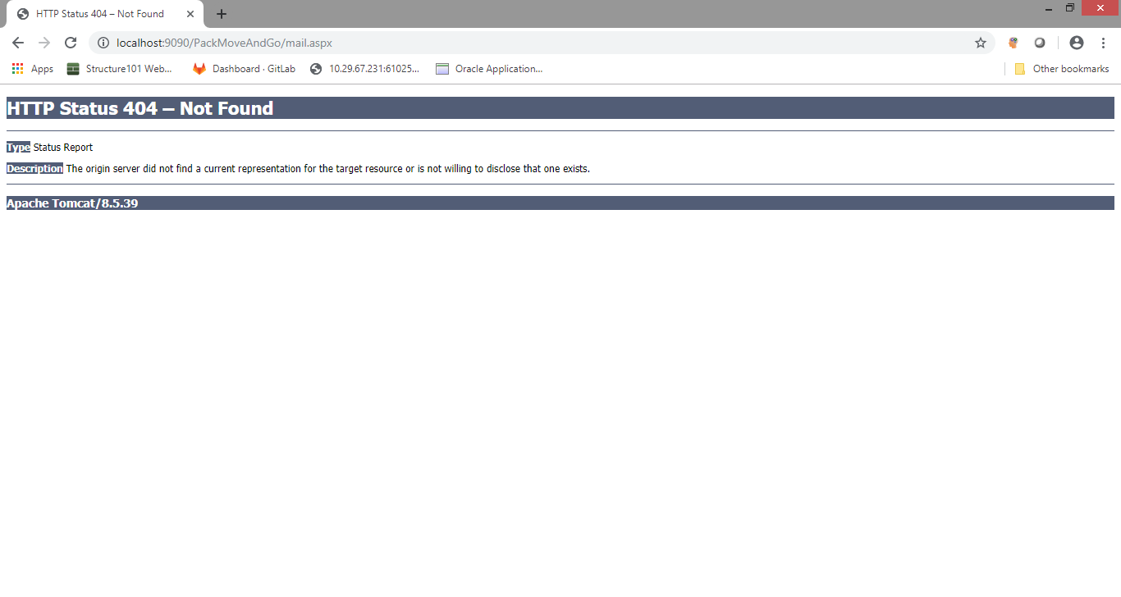

1. In consignmentStatus, table header is printed at below again: Done

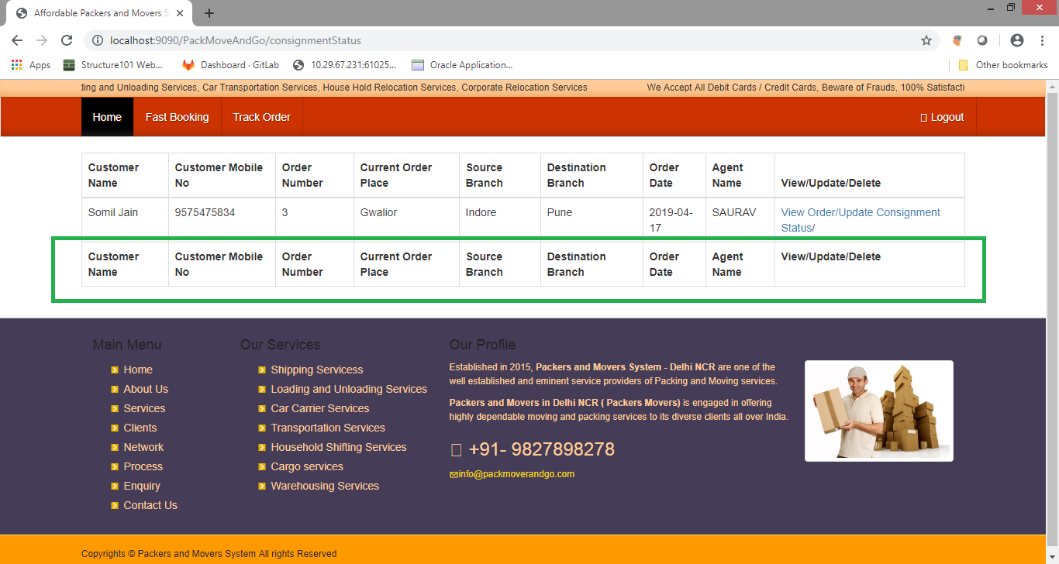

1. In above table change name of “Current Order Place” to “Current Status” :done
2. After login – if someone clicks on “Home”.. again it shows – Login button :done

Changes / yet to implement: Done

1. When booking happens these below options should come (as link) :Done
   1. Documentation of the consignment (way-bill, consignment bill,payment receipt).
2. In track order:Advance search with Customer name:Done
3. After User/Admin logs in – new tab “MIS Report” which should create report in page and in PDF:Done
   1. Monthly
   2. Yearly
   3. Date Wise
4. After delivery completed – proof of delivery should be uploaded – file/image uploaded.: Done
5. New column for Status of consignment – Order/Transit/Delivered :Done
6. Cancel booking :Done
7. Customer can search with his booking ID :Done